Software Architecture of the 8088/8086 Microprocessors
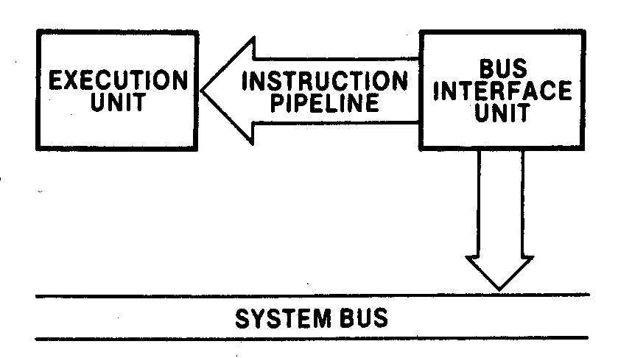
Pipelined architecture of the 88/86 microprocessors
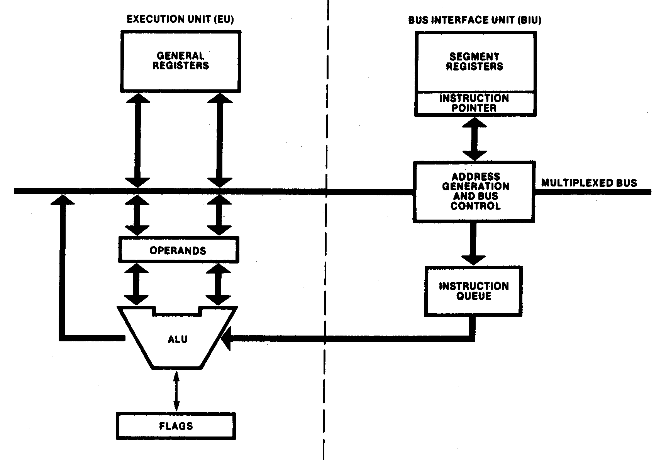
Execution and bus interface units
Software Model of the 88/86 Microprocessors
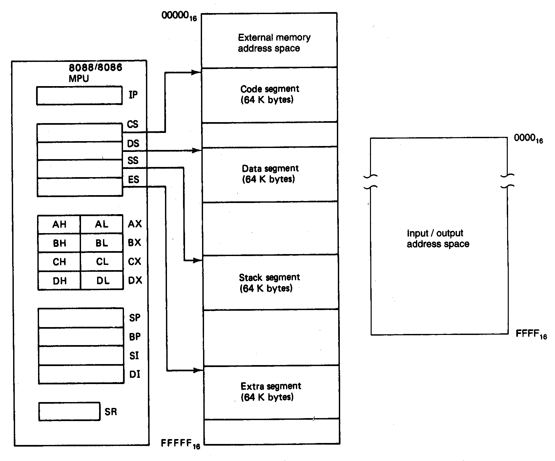
Memory Address Space
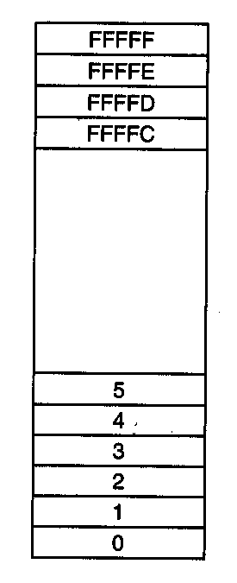
Memory address space

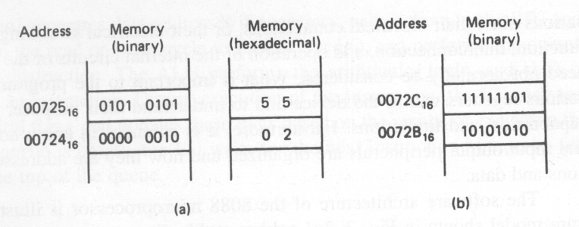
Storing a word in memory
What is the word in (b) in Hex?
Is the word stored in (b) aligned ?

Data Organization
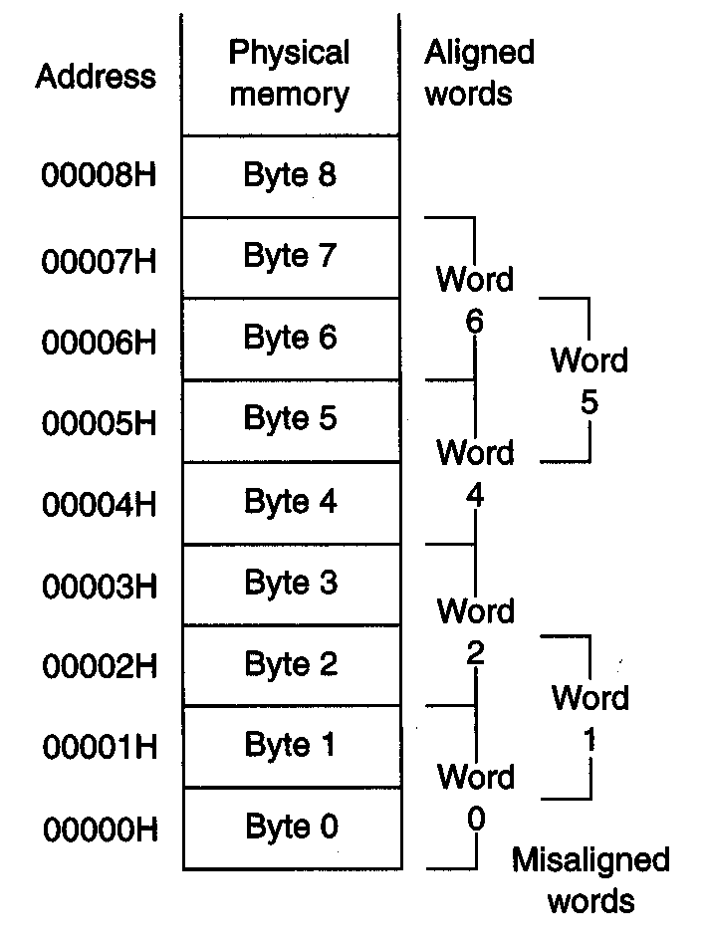
Aligned and misaligned data word
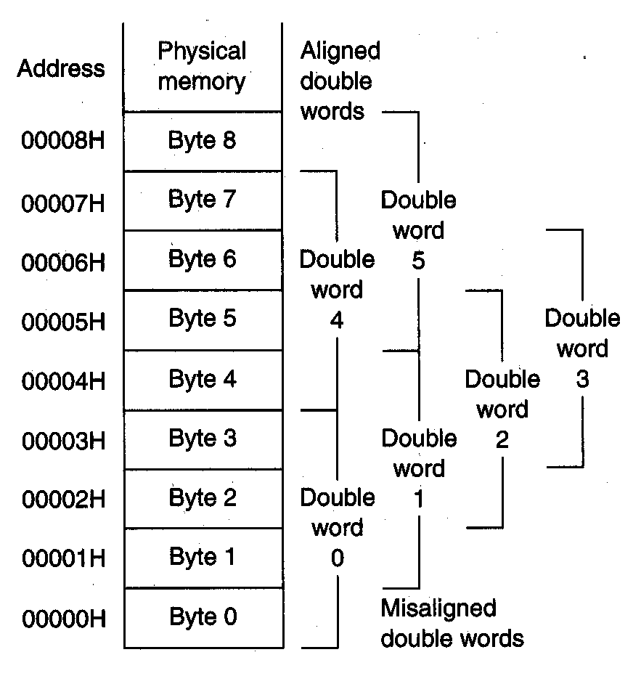
Aligned and misaligned double words of data

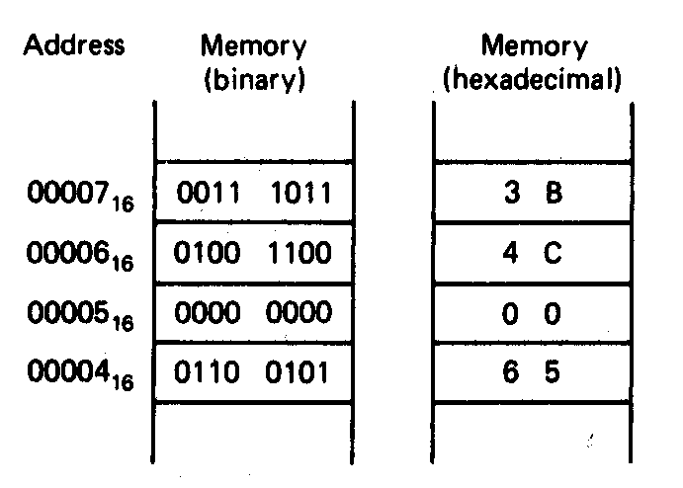
Storing double word in memory

Example:
How should the pointer with segment base address equal to A000H and offset address 55FFH be stored at an even-address boundary at 0008H?
Is the double word aligned?
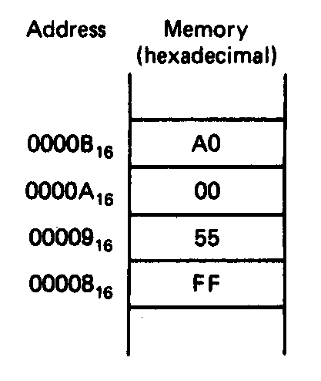

Data Types
Unsigned Integer
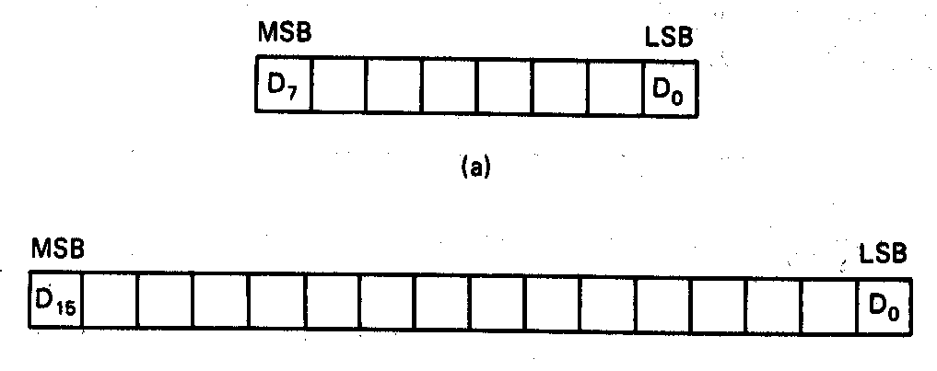
Unsigned byte integer (0 – 255)

Unsigned word integer (0 – 65,535)

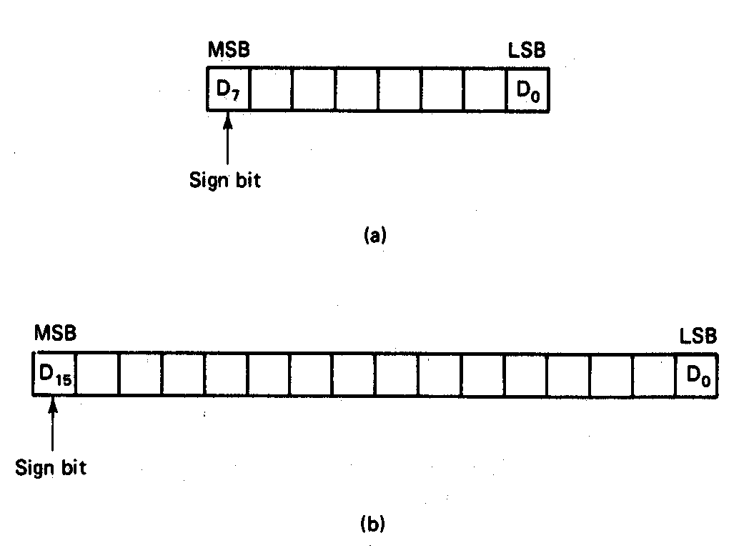
Signed Integer

-128 - +127

-32,768 - +32,767

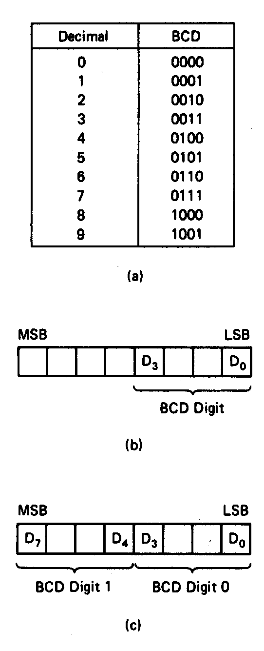

Unpacked BCD

Packed BCD

Binary Coded Decimal (BCD)

Example:
The packed BCD data stored at byte address 01000H equals 100100012. What is the two-digit decimal numbers?

100100012 =1001BCD 0001BCD = 9110

American Standard Code for Information Interchange ASCII
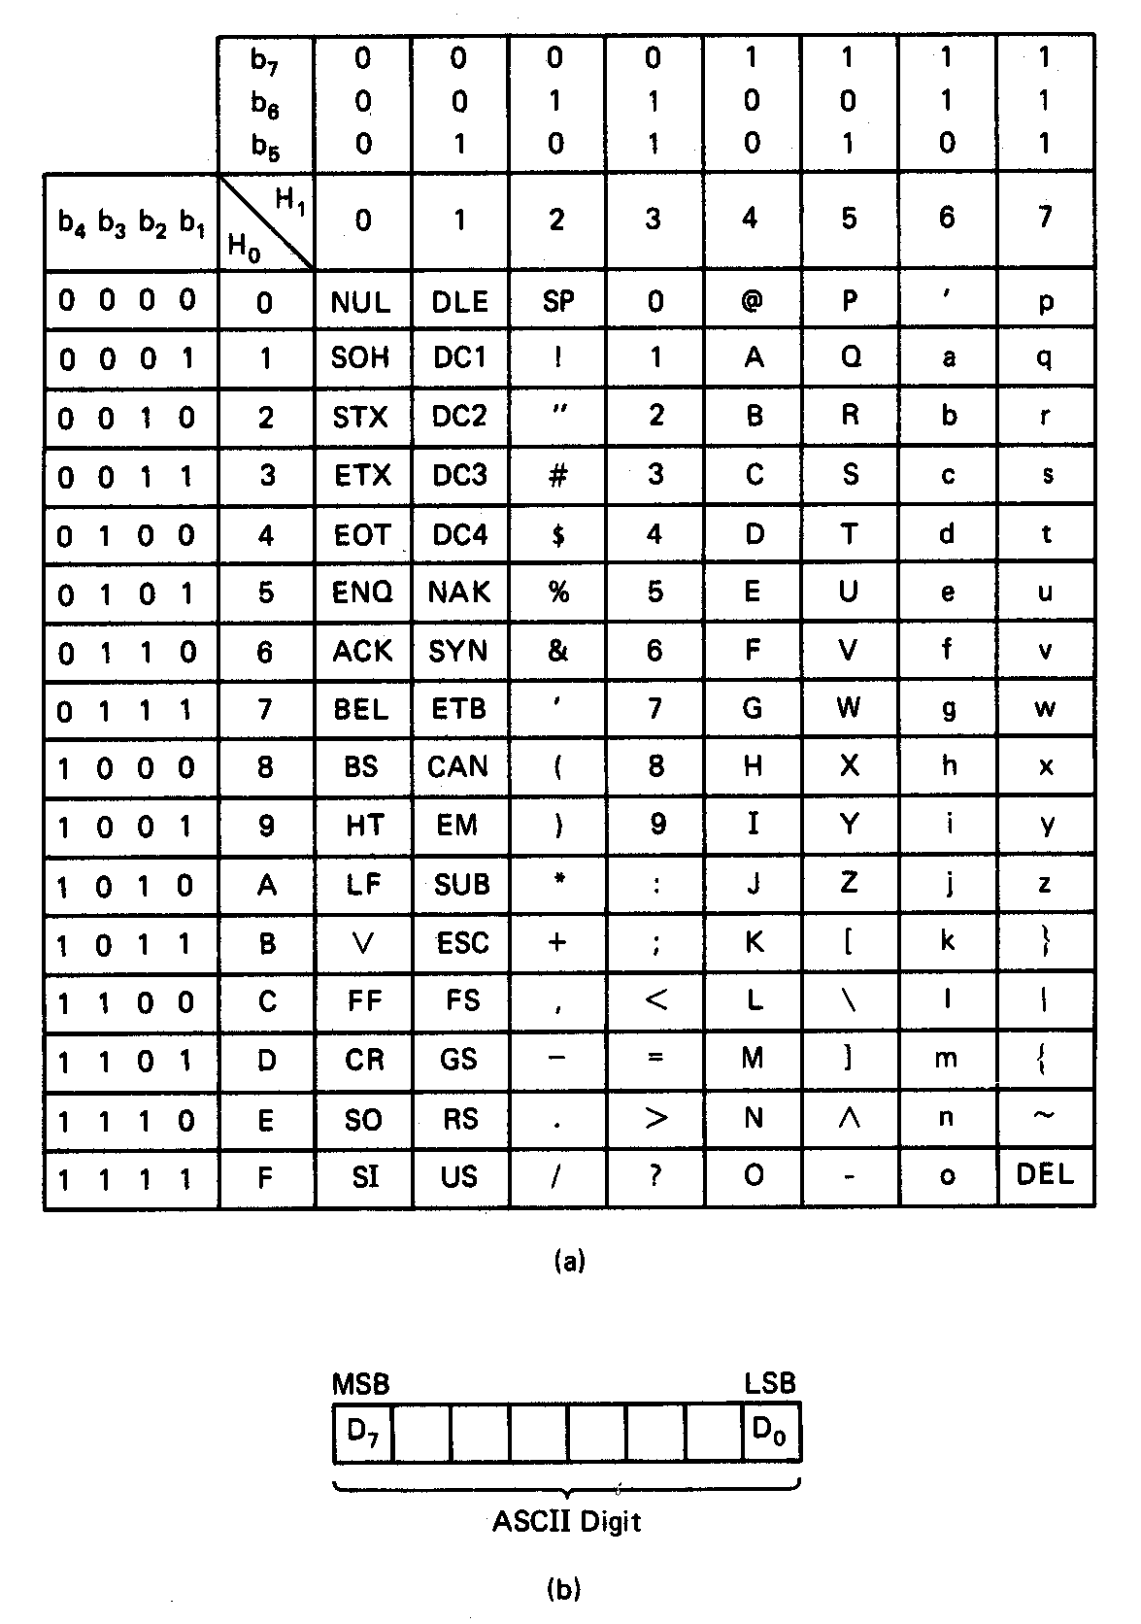

Dedicated, Reserved, and General use Memory
Some address locations have dedicated functions and should not be used as general memory for storage of data or instructions of a program.
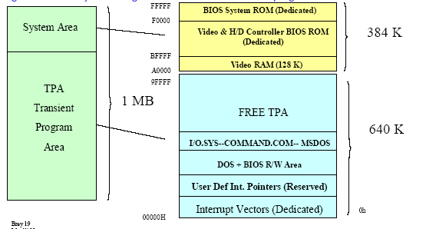
1MB=1,048,576

Data Registers
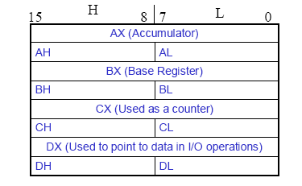
• Normally used for storing temporary results
• Each of the registers is 16 bits wide (AX, BX, CX, DX)
• Can be accessed as either 16 or 8 bits AX, AH, AL
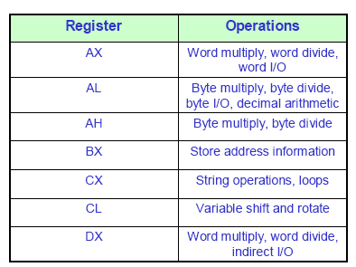
Pointer and Index Registers
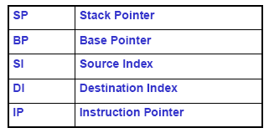
- All 16 bits wide, L/H bytes are not accessible
- Used as memory pointers
- Example: MOV AH, [SI]
Move the byte stored in memory location whose address
is contained in register SI to register AH
- IP is not under direct control of the programmer

Flag Register

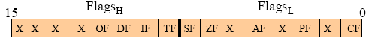

• Six of the flags are status indicators reflecting properties of the last arithmetic or logical instruction.
• For example, if register AL = 7Fh and the instruction ADD AL, 1 is executed then the following happen
AL = 80h
CF = 0; there is no carry out of bit 7
PF = 0; 80h has an odd number of ones
AF = 1; there is a carry out of bit 3 into bit 4
ZF = 0; the result is not zero
SF = 1; bit seven is one
OF = 1; the sign bit has changed
• Can be used to transfer program control to a new memory location; for example: ADD AL, 1
JNZ 0100h

Generating a Memory Address
• Addresses within a segment can range from address 0 to address FFFFh. This corresponds to the 64Kbyte length of the segment
• An address within a segment is called an offset or logical address
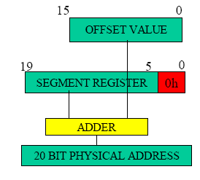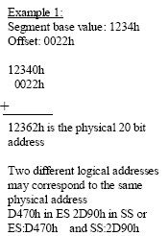
Example:
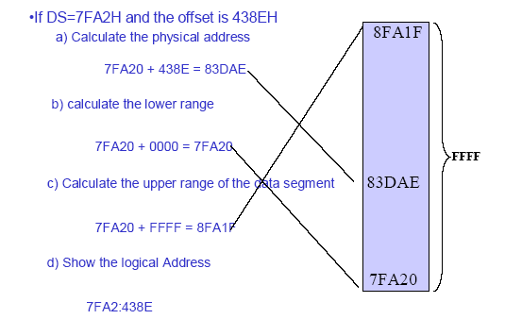

The Stack
- The stack is used for temporary storage of information such as data or addresses; for instance when a CALL is executed the 8088 automatically PUSHes the current value of CS and IP onto the stack.
• Other registers can also be pushed
• Before return from the subroutine, POP instructions can be used to pop values back from the stack into the corresponding registers
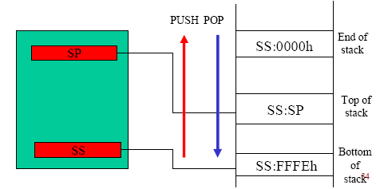
Example for PUSH
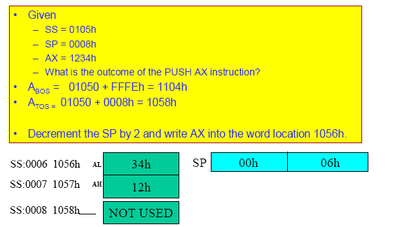
Example for POP
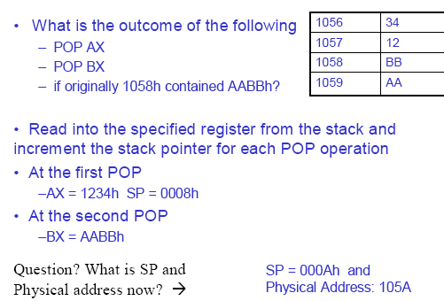

The I/O address space
Some processors map I/O devices in their own, separate, address space; others use memory addresses as addresses of I/O ports. Both approaches have advantages and disadvantages. The advantages of a separate address space for I/O devices are, primarily, that the I/O operations would then be performed by separate I/O instructions, and that all the memory address space could be dedicated to memory.
Typically, however, I/O is only a small fraction of the operations performed by a computer system; generally less than 1 percent of all instructions are I/O instructions in a program. It may not be worthwhile to support such infrequent operations with a rich instruction set, so I/O instructions are often rather restricted.
In processors with memory mapped I/O, any of the instructions which references memory directly can also be used to reference I/O ports, including instructions which modify the contents of the I/O port (e.g., arithmetic instructions.)
Some problems can arise with memory mapped I/O in systems which use cache memory or virtual memory. If a processor uses a virtual memory mapping, and the I/O ports are allowed to be in a virtual address space, the mapping to the physical device may not be consistent if there is a context switch. Moreover, the device would have to be capable of performing the virtual-to-physical mapping. If physical addressing is used, mapping across page boundaries may be problematic.
If the memory locations are cached, then the value in cache may not be consistent with the new value loaded in memory. Generally, either there is some method for invalidating cache that may be mapped to I/O addresses, or the I/O addresses are not cached at all. Memory and I/O Address Spaces
The Motorola 68000 processors use conventional memory read and write (MOVE) operations to do input and output. Peripheral interfaces appear to the processor as if they were memory locations.
The 80x86 processors can also use this type of “memory-mapped” I/O but they also have available special instructions (IN and OUT) for I/O operations. A bus signal indicates whether a bus cycle is due to a memory or an I/O instruction. These special I/O instructions allow more flexibility in the design of interfaces (e.g. extended cycles for I/O operations). I/O operations can only be done on the first 64kB of the I/O address space.
On the IBM PC and compatibles only the first 4k of this I/O address space is available (0 to 3FFH).

Alternate Device Access Interfaces
While having a driver implement all device accesses using the and family of interfaces, 8086 provides interfaces specific to particular bus implementations. While these functions are more efficient on some platforms, use of these routines can limit the ability of the driver to remain portable across different bus versions of the device.

Memory Space Access
With memory mapped access, device registers appear in memory address space. The family of routines and the family are available for use by drivers as an alternative to the standard device access interfaces.

I/O Space Access
With I/O space access, the device registers appear in I/O space, where each addressable element is called an I/O port. The family of routines is available for use by drivers as an alternative to the standard device access interfaces.

